DIKULT 105: Web Design 1

Autumn 2013

Assignement 2:

Report

RED

<http://www.kurs.uib.no/dikult105/submit/assignment2/6www/>

248 words

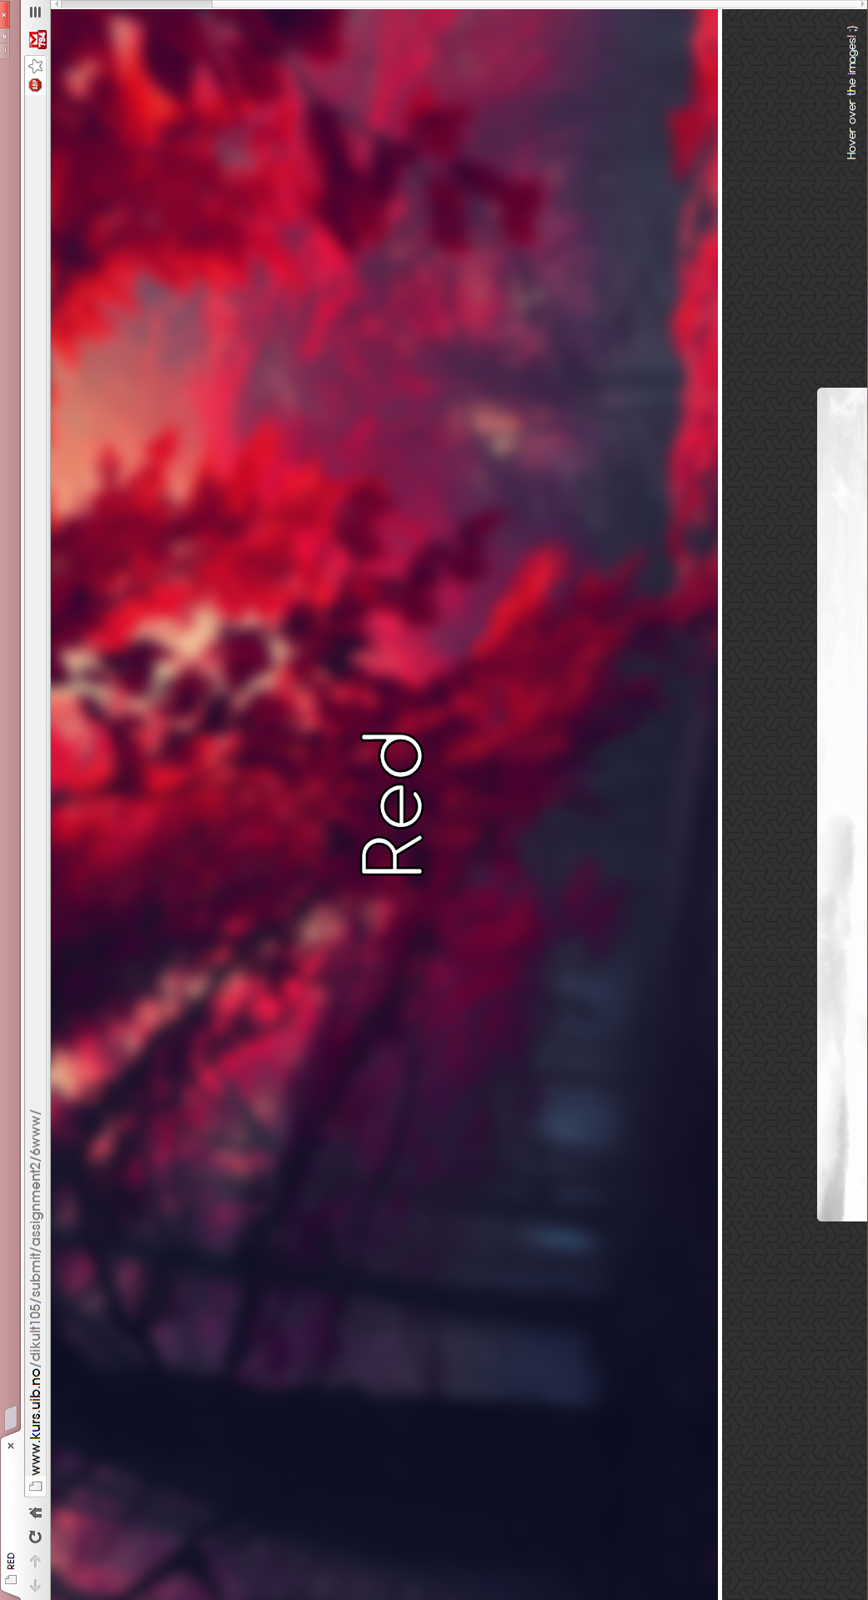

Figure : Story (Chrome 29.0.1547.76 m)

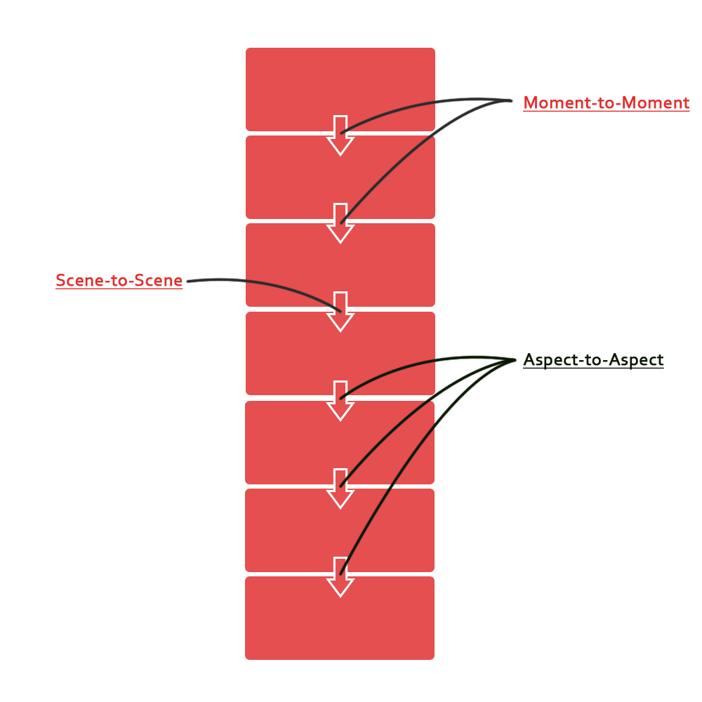

# RED

After reading the assignment, I immediately knew which picture I was going to choose, but not how to incorporate the story into pictures. Therefore, I read up on (McCloud 1994) where I learned more about the different ways transitions work. Seeing as how spacing and how different pictures in sequence really affects how the reader looks at (understands) the intended purpose of the story.

Uncertain whether or not the pictures and the storytelling paragraphs gives the same impression as I intended, but nonetheless all the elements that inspired me is there to inspire the readers as well.

I was uncertain if it would come natural for a reader to hover over at least one of the pictures in the story, and thereby revealing the pictures other nature, along with the narrative story. That is why I decided to have a text fixed in the lower right corner, to give instructions to the reader. Although this could probably have been done in a more slick fashion, by using an alternative method of displaying/changing the nature of the image.

## The design process

The site was constructed with one idea in mind, and through trial and error, I finalized my idea. Although the webpage works perfectly as to its intended purpose, the base skeleton of the webpage could probably do with some optimization and simplification.

## the design tools

I used tools as Adobe Dreamweaver cs6, as well as Notepad++, and I mostly used Google Chrome as my test browser(although I checked it up with Mozilla Firefox every now and then) seeing as it is my browser of choice.

# References

McCloud, Scott. 1994. *Understanding Comics.* New York: HarperCollins.